* LCD With Arduino:-

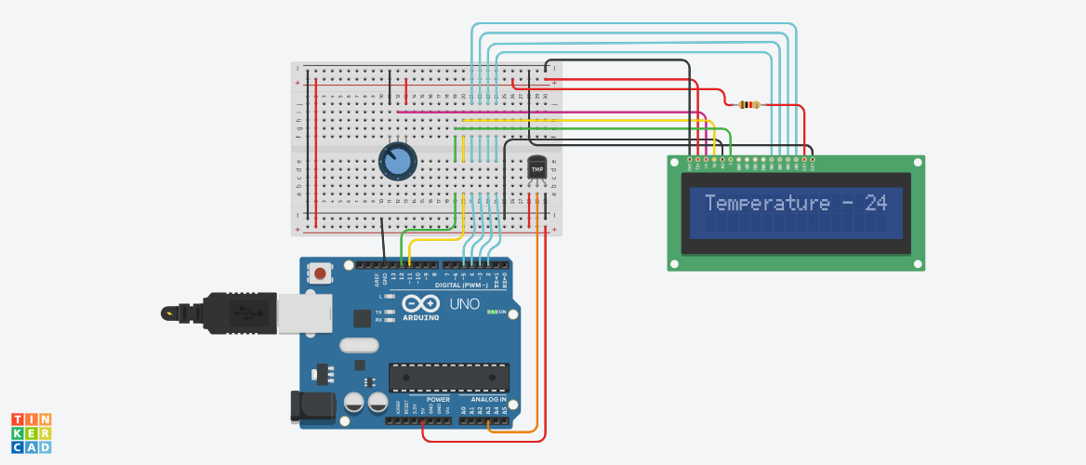

**Circuit diagram**

* **Description :-**

In this project we display the temperature by using Arduino, Temperature sensor and potentiometer. The basic principle of the potentiometer is that the potential drop across any section of the wire will be directly proportional to the length of the wire, provided the wire is of the uniform cross-sectional area and a uniform current flow through the wire.

* **Application :-** 
  + - * + Temperature sensing device.
        + In automation Machine.
        + Where using Heating Component Like in Heater.
        + Other Electronic Components that display Temperature related information.
* **Working Principle:-**

When you run the code, the current temperature will be displayed on the LCD on the top row. Its working by temperature sensor.

* **Circuit Connection :-**

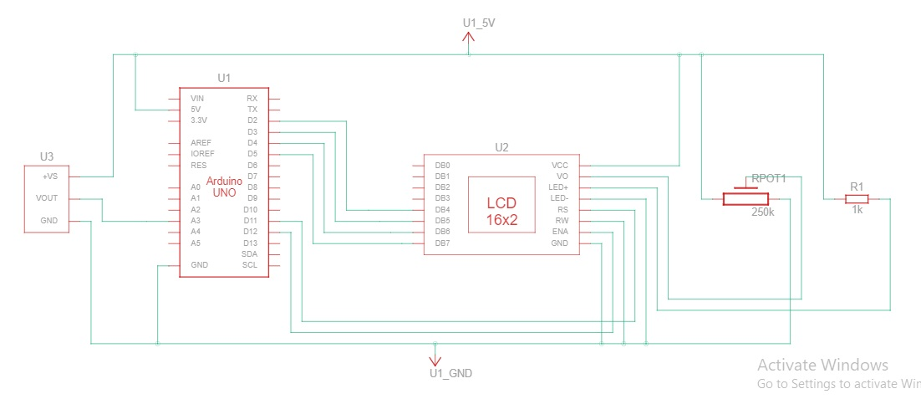

* **Component List :-**

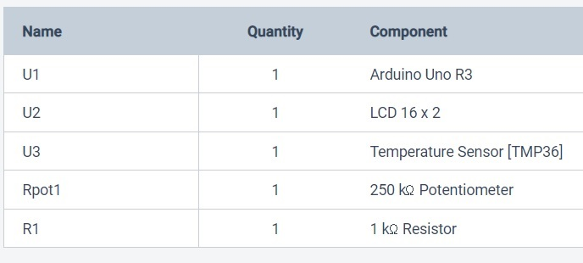

* CODE :-

#include <LiquidCrystal.h>

// LCD pins <--> Arduino pins

const int RS = 11, EN = 12, D4 = 2, D5 = 3, D6 = 4, D7 = 5;

LiquidCrystal lcd(RS, EN, D4, D5, D6, D7);

int TMP = 0;

void setup()

{

pinMode(A3, INPUT);

lcd.begin(16, 2);

}

void loop()

{

TMP = (-40 + 0.488155 * (analogRead(A3) - 20));

lcd.setCursor(0, 0);

lcd.print("Temperature - ");

lcd.print(TMP);

}